Design Review has this cool feature where you can compare drawings. Through the magic of API programming, Jan Liska from Autodesk Consulting has hooked this functionality to Vault. The tool is called Drawing Compare and it easily lets you compare two drawings or two revisions of a drawing from within Vault.
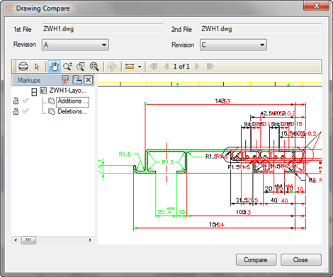
Requirements:
Vault Workgroup / Collaboration / Professional 2012
Autodesk Design Review 2012
Click here to download the application
To Use:
- Run the installer.
- Run Vault Explorer.
- Select two drawings or two revisions of the same drawing.
- Right-click and choose Compare Drawings.
- In the pop-up window, click the Compare button.
You can also run Compare Drawings after selecting a single drawing. In this case, the Drawing Compare window will have combo boxes that let you select the revisions that you want to compare.
The tool only works on drawings that have DWF files.
As with all the samples on this site, the legal disclaimer applies.

